**4TEAM ID:** PNT2022TMID04459

**PROJECT NAME:** VISUALIZING AND PREDICTING HEART DISEASE WITH INTERACTIVE DASHBOARD

Final Prediction

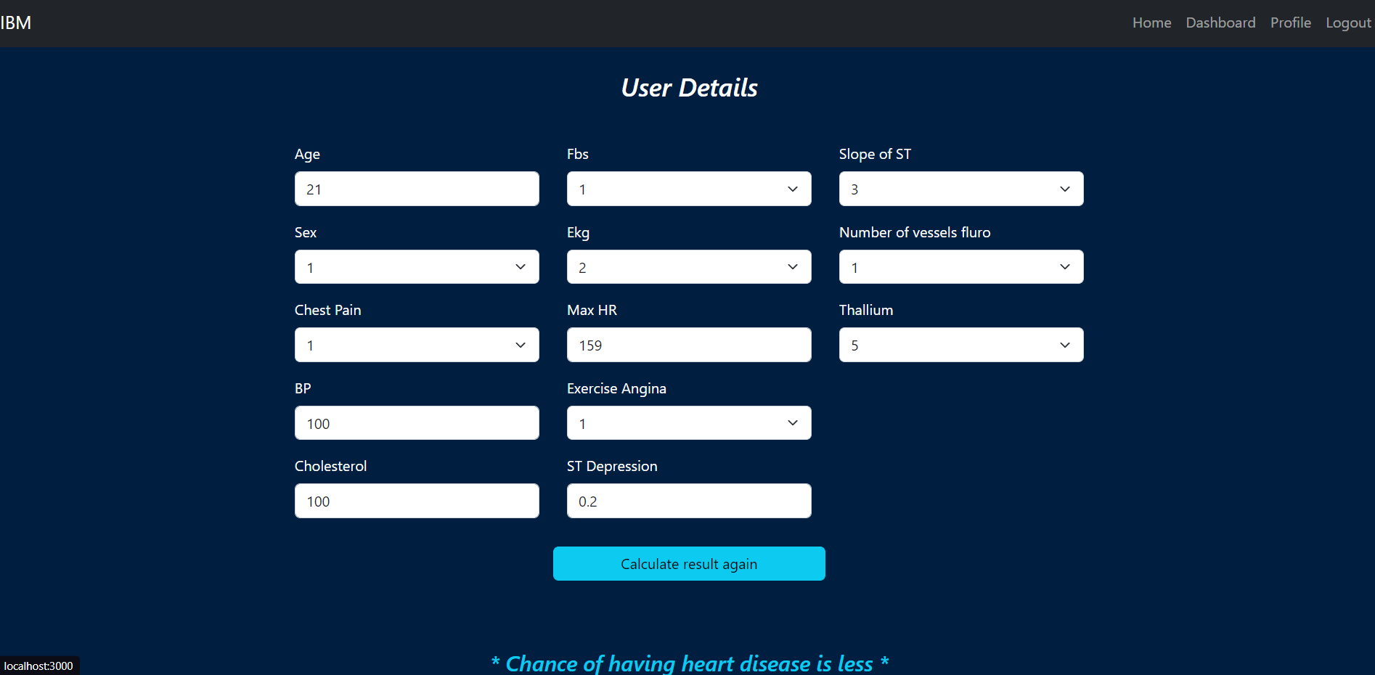

Rating

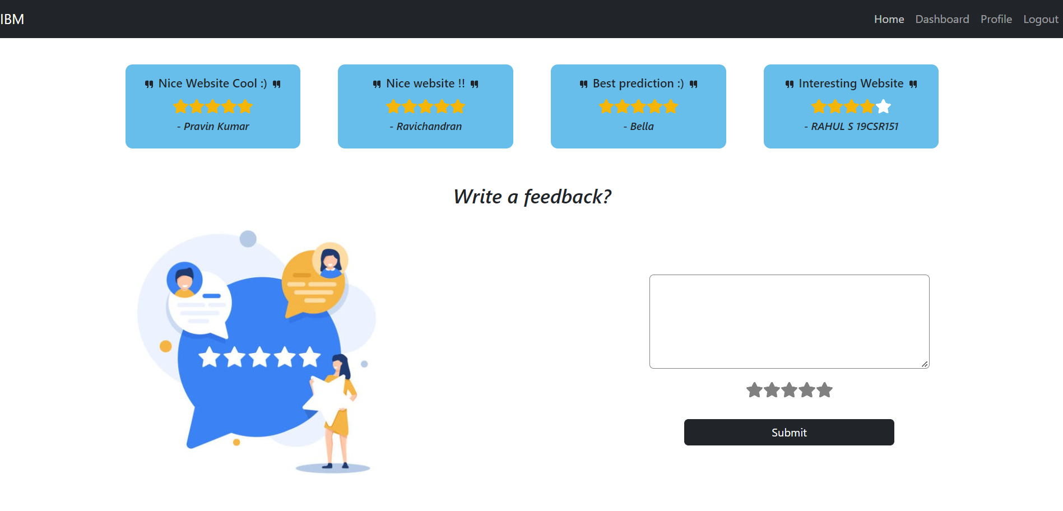

Queries

